Dodson, the Bilingual Method and Classroom Pronunciation Experiments from the 1960s
Abstract
In 1967 – exactly 50 years ago – Dodson published the results of a set of classroom experiments which included the teaching of pronunciation. The language teaching method that emerged was revolutionary in the context of contemporary beliefs and practice in British schools. Pronunciation was integrated as a prominent feature in a holistic methodology, alongside grammar, vocabulary, discourse conventions and confidence building in speech, listening, reading and writing. He discovered that pronunciation proficiency was most successfully developed through a rapid imitation procedure, both individually and ‘chorally’, of narrative material that was understood and meaningful, and was reinforced by corresponding print as an out-of-focus secondary aid. His strategy led to both immediate conversation ability and long-term consolidation. The settings of the experiments were a primary school class of 26 8 and 9 year old children and 5 classes of 13 and 14 year old pupils in a secondary school. Still relevant today.

One of the many points to be applauded in Derwing & Munro (2015) is the acknowledgement of past efforts of decades ago in pronunciation experimentation which have not received due attention by the present generation (p 26). Either the researchers were then simply ahead of their time or their findings were too much of a challenge to contemporary conventional wisdom. I believe that Dodson (1967) is a case on both accounts. When Derwing & Munro (2015: 49) then admitted that “we do not know of any true experimental studies of pronunciation instruction”, Dodson’s work came to mind again.

Carl Dodson was the son of a German mother and English father but grew up initially in Germany; but the family fled from Nazi Germany and settled in UK. Carl began British school life without any knowledge of English, and it was his experiences of gaining competence in English that inspired him to engage in research into language learning and teaching. He realized that any new gain in English at first was interpreted in his own mind into German, as a way of understanding what was meant. He also realized that he not only needed the new vocabulary of English, but also the grammar to put messages together in a coherent fashion, the manner of making those messages (discourse conventions), and abilities to comprehend what was said to him, to say messages in an accurate and fluent way to others, to read with comprehension and to write competently.

The prevailing method in British schools in the 1950s and 60s was the ‘grammar-translation’ method, with its emphasis on reading, writing, translation exercises and learning vocabulary lists by heart. But that was not how he had learnt English in his own experience. On the other hand, the prevailing method of teaching English as a foreign or second language abroad (TEFL/TESL) was the ‘situational’ method, where learners were introduced to the language of different situations like shopping, booking a hotel room, etc. This was conducted entirely in English in what had been known as the ‘direct’ method; reference to the learners’ mother tongue was eschewed both on practical grounds and ‘philosophical’ grounds, with reading and writing demoted too. This method was promoted by the British Council and was totally opposite to what was being promoted in British schools. Meanwhile, academics and publishers began producing audiovisual methods on the same principles for higher education (eg Linguaphone) and soon language laboratories were to make their debut with audiolingual ‘structural’ materials.

Dodson was dissatisfied with the demotion of speech and the reliance on mother tongue translation on one hand, but also with the total rejection of any role for the learners’ mother tongue and the demotion of reading and writing, on the other. His ‘Bilingual Method’ gave a limited, but precise, role to the mother tongue, developed accuracy and fluency in speech, reinforced comprehension, practised grammar, reading and writing, turned dialogues into question and answer sessions as a way of encouraging learners to engage in real, personal, competent communication in both speech and the written mode.

His methodology was ultimately based on the findings of his experimental work which developed from hunches from his own experience. Although it did not gain broad acceptance in British schools, it did inspire the teaching of Welsh to adults and eventually also in the schools of Wales, where there was considerable determination to ‘save’ the language. It did not make any inroads into British Council policy, although some teachers in Germany made successful use of it (Butzkamm 1980), as did many in India, including the Bangalore and Madras English Language experiments described in Prabhu (1987).

This article is not the place to review the whole of the ‘Bilingual Method’ (see Tench 1988; Caldwell 1990), but to focus attention on the experiments that led to successful teaching of pronunciation in the classroom. However, it must be borne in mind, that pronunciation was only one element in a comprehensive, holistic enterprise in language teaching and learning. But it was a valued, integrated, skill that was given due prominence to achieve successful interaction and effective communication. His experiments were devised with this integrated task in mind. (It must be borne in mind, that the 1960s precede the era of modern quality control in quantitative research design in applied linguistics; so a measure of tolerance would be appropriate 50 years on!)

Classroom experiments

In his definitive set of experiments, Dodson engaged on the one hand 26 primary school pupils aged 8 and 9, and on the other 130 secondary school pupils aged 13 and 14.

The primary school children had already been taught a language for a year, but with a variety of modes in presenting the meaning of the sentences they learnt: using objects, actions, pictures and in various combinations. In this way, these young children were prepared for the experiment which involved the presentation of distinctly different modes:
1a: three sets of L2 sentences (eg Le crayon est sur la table), relevant pictures, the printed version of the sentences
1b: as for 1a, but without the printed version
2a: three sets of L2 sentences, the mother tongue equivalent, relevant pictures, the printed version of the sentences
2b: as for 2a, but without the printed version
3: three sets of L2 sentences and the mother tongue equivalent, but no other support.

Each child was tested separately away from the classroom. Every sentence was spoken 15 times by the tester. The child had to imitate each spoken stimulus. After every third imitation response, the child was asked to give the meaning of the sentences they were imitating, ie 5 meaning checks for each sentence. For sentences 2a and 2b, a correction of meaning was given, if necessary, after the third meaning check. Although imitation was the main procedure at this point, the tester’s interest was in the acquisition/retention of meaning. The results appear in Fig 1.

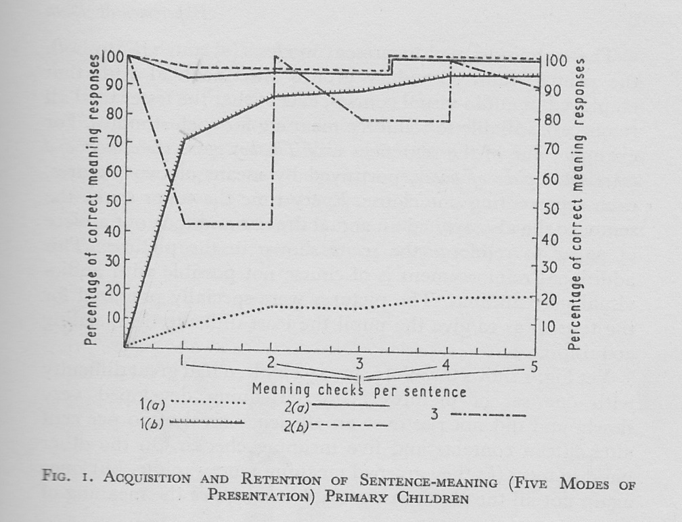

The graph shows that one group of sentences (1a) was very poorly understood throughout the experiment; another group (1b) was more immediately successful in that 70% of the children had acquired the meaning early on, but it took another 12 attempts for the success rate to achieve 95%. This meant that one or two children never understood properly the meaning of all the sentences, despite the pictures. The best results were obtained for the groups 2a and 2b, which had both pictures and the mother tongue equivalent in common. Group 3 sentences were revealing: with no picture to aid retention of the meaning, the mother tongue equivalent alone was not effective for meaning retention for more than half of the children. All this suggests that the best strategy to maintain understanding while engaged in an imitation exercise is to provide a mother tongue equivalent with visual aid support. It also suggests that if meaning is not acquired early, there is no guarantee that it will be acquired at all.

For the secondary school pupils, 5 groups of 30 were assembled and matched for academic ability. In their case, no previous exposure to the new language had been received. The testing procedure was conducted as above, with the same goal of testing meaning acquisition/retention. The results appear in Fig 2.

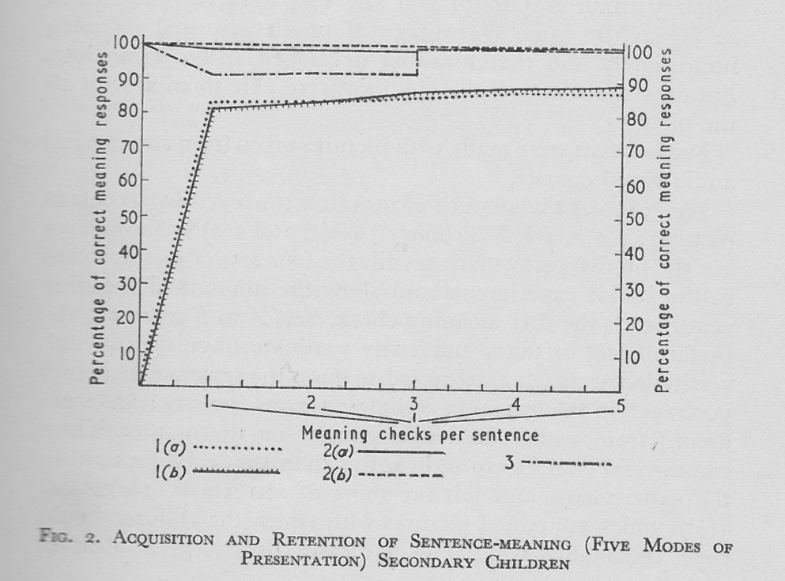

The most immediate impression is the difference that a few years of maturity make. Nevertheless, still 20% did not acquire meaning from the sentences of groups 1a and 1b, and even after another 12 attempts, still at least 10% failed. Again this suggests that meaning does not necessarily develop with extra oral exposure and practice. Pupils who were presented with the sentences of groups 2a, 2b and 3 performed best, retaining meaning more or less throughout while engaged in an imitation activity, with less dependence on visual aids.

Incidentally, Dodson then tested the effectiveness of contemporary (1960s) commercial audiovisual courses on 30 university students and lecturers in acquiring the meaning of their materials. The methodology relied on the perspicuity of the visuals to convey meaning, but as Fig 3 shows, it was not very effective. 1(a) and (b) P refer to the primary children’s results for meaning acquisition at the first meaning check; 2(a) and (b) S to the secondary school results; and A to F refer to the results from materials watched by the students and lecturers.

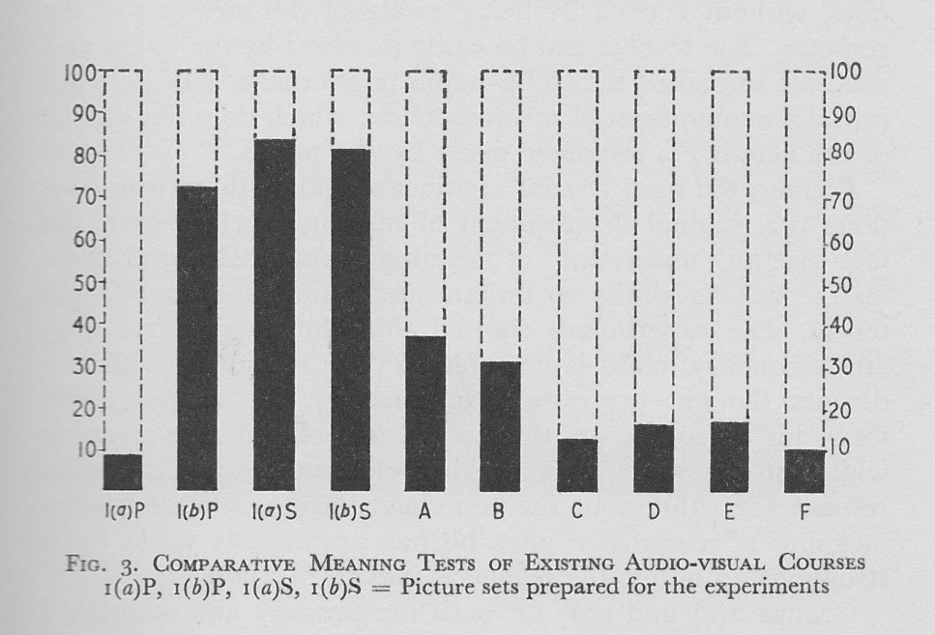

Dodson used these results not only to recommend further research on visual aid design, but also to demonstrate that visual aids alone are not necessarily adequate for showing meaning. He felt he could also show that meaning is not necessarily acquired the longer a learner engages in an activity that does not directly contribute to understanding. (He also admitted a problem with the design of their own picture accompanying group 1a sentences for the younger children.)

Imitation

We turn now from meaning to the actual activity of imitation itself as a procedure for developing pronunciation proficiency. So, not only was understanding checked but pronunciation was also evaluated.

With the primary school children, Dodson (1967: 12) decided to ditch group 3 sentences, ie those not accompanied by a picture, because most of the children had forgotten the meaning without the visual support. He was simply not interested in measuring pronunciation proficiency for the sake of it, if an activity could not guarantee a good measure of understanding. The remaining modes of presentation were maintained, and imitation proficiency was measured during the course of the experiment, concluding with the 15th response. Each child had to satisfy the tester in both accuracy and fluency of the sentences and individual sounds; both the accuracy and fluency of each response was required to be accepted as satisfactory. A control group of children was used to counter any discrepancy between the levels of pronunciation difficulty within the sets of sentences. The results are shown in Fig 4. (For some reason Dodson introduced letters A to D for this graph.)

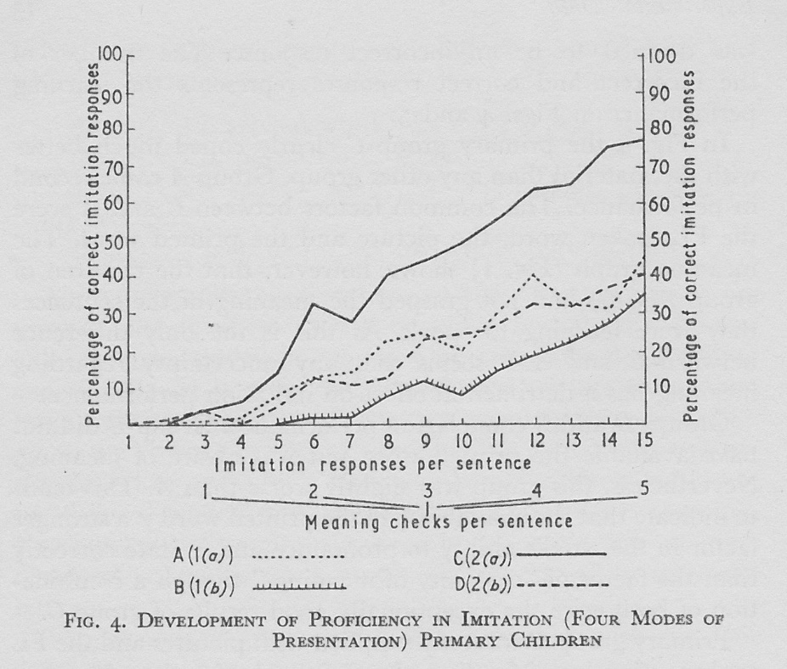

Fig 4 shows the gradual improvement in imitation proficiency during the course of the experiment, but one mode of presentation was outstanding, C (2a): three sets of L2 sentences, with the mother tongue equivalent, relevant pictures and the printed version of the sentences. Group 1a lacked the mother tongue equivalent; 1b lacked both the mother tongue equivalent and the printed version; group 2b lacked the printed version.

He hypothesized that the most efficient way to conduct an imitation activity for young children, and so, encourage pronunciation development, required satisfactory provision of meaning with visual support and the printed version. In other words, it strongly suggests that if the children are confident in their understanding of the meaning of sentences, they can become more proficient in pronunciation. If children are left guessing meaning, they do not concentrate fully on the imitation activity; it is as if they cannot easily concentrate on two different new aspects of the communication. This last point has been endorsed by other, independent, researchers, eg Bley-Vroman & Chaudron (1994: 248): Semantic “processing might in principle place a load on working memory … If it does, then foreign-language learners will, in effect, have less memory available for the imitation task, hence their lowered performance”.

The secondary pupils were measured on their imitation responses for each of the five modes of presentation, Dodson adding E for the original group 3. Fig 5 shows their results.

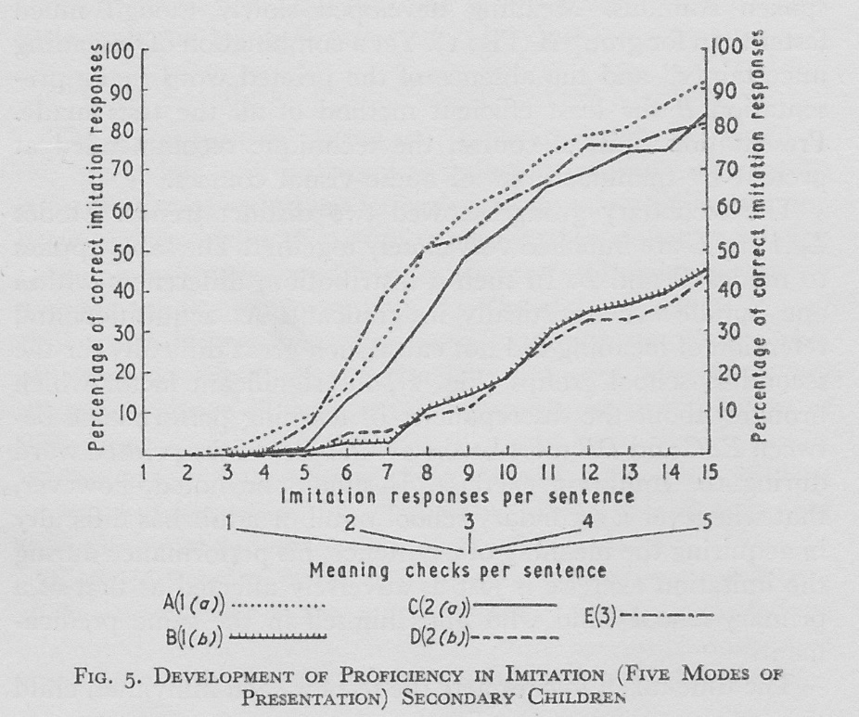

This shows a remarkable convergence of results into two categories. The common factor here was the presence or absence of the printed version as a support. The best outcomes for pronunciation proficiency, therefore, combined the mother tongue equivalent, pictures and the printed version. Coupled with the results for measuring the acquisition/retention of meaning, it seems therefore that as long as the pupils immediately understand the meaning of the sentences that they are learning, and the printed version is available, both pronunciation and understanding flourish. He also pointed out that conducting the experiments with the mother tongue equivalent providing initial meaning and with printed material were executed much more quickly, often twice as quickly (Dodson 1967: 15). This is obviously an important factor in the management of time in the classroom.

Written support

Dodson was intrigued by the discovery that the printed version seemed to contribute a significant role in the development of an oral skill. This challenged the presuppositions of contemporary audiovisual course methodology and the situational method.

He surmised that the secondary pupils had been exposed to the written word for long enough to establish a kind of automaticity in reading and a reliance on the printed word. But for the primary school children the position was different. They were still at the stage of acquiring reading and writing skills in their mother tongue; these skills, and spelling, still constituted a task of some effort. So he decided to conduct further experiments with the primary school children to see how they benefit from the availability of the printed version of the sentences they were practising.

The simplest experiment involved learning to pronounce the numbers 1 to 20 in the L2 (in this case German). Numbers 1 to 10 were given both as digits (a simple visual aid) and as spelled words; numbers 11 to 20 were given simply as digits without a spelled version. Note that numbers 13 to 19 in German involve directly the numbers 3 to 10, and so the extra learning effort is comparatively small. He reported that “the number of contacts and time taken to master 11-20 was far greater than that required for 1-10” (p 22). He repeated the experiment with groups of undergraduates in three different languages (German, French and Welsh), and found that “the results were identical to those obtained with primary children” (p 22). The learners somehow benefitted from the availability of the printed version.

A more elaborate experiment was conducted with a whole class of primary school children, involving two sets of narrative with six sentences of equal length and pronunciation difficulty. One set was accompanied with a picture strip, the other with just the printed version. For each sentence, the mother tongue equivalent was given, to eliminate any problem with understanding. The goal was to bring the children to a point where they could all imitate the L2 sentences accurately in individual sounds and fluently as sentences.

Dodson emphasized that the printed version was not handled in the traditional ‘grammar-translation’ manner. There the printed form was a primary focus: a learner looks at it, reads it, analyzes it, and on the basis of it, attempts to render that sentence into the other language. By contrast, Dodson wanted to maintain the spoken stimulus as the primary focus and have the printed version simply as a secondary aid, “out of focus”. The teacher would say the L2 sentence, then briefly the mother tongue equivalent, then the L2 sentence again three or four times, all the while requiring constant eye contact from all the children, so that they would concentrate on the sound of the sentence, without access to either the picture strip or the printed version. The teacher would then call on individual children to imitate the L2 sentence, but they were not allowed to consult the picture strip or printed version while doing so. Each individual child had to concentrate on imitating the teacher’s spoken stimulus. However, while one child was responding, the other children were allowed to look at their picture strip or printed version, but as they were doing so they were still hearing the spoken stimulus and so were able to associate the sentence with the printed words (or the picture strip). In fact, they were encouraged to follow the sentence silently in their minds as they heard it. The printed version had one extra bonus, that if a child suffered a complete breakdown while responding, they would then be allowed to consult it, as a cue to help them.

The set of six sentences without the printed version but with the picture strip took almost three times as long to teach as the parallel set with the printed version and without the picture strip. The teacher required more than twice as many spoken stimuli for the first set than the second: 186 and 86. The children had to make 50% more attempts at responding in the first set over the second: 240 and 161. Their average number of responses were 6.9 per minute in the first set, but 12.9 in the second. In other words, the availability of the printed word as a secondary ‘stimulus’ was far more efficient than the availability of the picture strip.

But what might the benefit of the printed version as a secondary stimulus be? Dodson speculated (p 19-22) that learners benefit from knowing what the individual words were rather than just responding to a mass of sound; it seems that the initial letters were enough to help a learner to ‘steer’ through a sentence; that otherwise learners ‘invent’ their own spellings as a help – which they eventually have to undo when they are presented with standard spellings. Because the speed of the responses is quicker with the printed version available as a secondary stimulus, it means that the learners could better exploit those 5 to 10 seconds when an accurate auditory image is retained by the brain; this enables them to acquire better pronunciation and more quickly. It gives them time to concentrate on accuracy of vowels and consonants, and to consolidate them.

A third experiment was conducted using a longer narrative of 12 sentences. Alternate sentences were either accompanied with a printed version, or not. All 12 sentences were taught in similar fashion and followed up with a question and answer technique. The children were then asked to repeat any sentences that they had practised; they invariably recalled better those sentences that had been accompanied with a printed version. “It seems that these sentences were more securely consolidated than those learnt without the printed word” (p 23).

In a final experiment, a list of words was drawn up containing items learnt orally either with or without printed versions and also new words with matching spellings. Each individual child was then asked to read the word list. The children managed best with those words they had previously learnt orally and with printed versions; they mis-pronounced “a large proportion” of the words learnt only orally; and they “usually” mis-pronounced the new words even though spellings matched: they had learnt Haus and neun, but not all them could manage the new words Maus and neu (p 24).

Furthermore, negative orthographic transfer proved not to be a hindrance for the children. The students also in the first experiment were able to contend with not only a transparent orthography (Welsh), but also with a semi-transparent (German) and a relatively non-transparent orthography (French). Dodson maintained (p 25) that interference is eliminated and oral proficiency increased when
- the learner does not look at the printed word for the first three or four L2 spoken stimuli, and
- the learner looks at the printed word when either the teacher or members of the class are saying the L2 sentences, and
- the learner says the L2 sentences in their mind during b), and
- the learner is made to ignore the printed word while actively responding, so that they are forced to rely on a mental image of the printed word during their response, and
- the learner is allowed to look at the printed word during a repeat response when their initial response has broken down.

With the availability of the printed version, learners gain an incidental acquaintance with the written form of the language. I discovered in my own experience that when I followed the above ‘procedure’ that I could even test that acquaintance through a simple dictation exercise – not, I hasten to add, a dictation test – by asking my learners to write out the sentences they had just been practising orally. Although I did not quantify their success, it was nevertheless quite impressive, and it did not take much effort on their part to correct their written attempts. In this way, they had learnt not only to understand the sentences of a narrative, but they could pronounce them and write and read them successfully too. Pronunciation had been integrated with meaning, writing and reading. No doubt the involvement of the eye as an extra sense in addition to the ear had helped to consolidate this process.

Age

The differences in the results between the primary school children and the secondary school pupils lead to the issue of the age factor, and Dodson had a number of observations to share. Incidentally, he discovered that intellectual ability (IQ) made no difference in the performance of imitation activities. Some pupils with a high IQ “gave a considerably worse performance” (p 30) than others with a relatively lower IQ. However, those with a high IQ did much better at other activities involving grammar and vocabulary, while those with a relatively lower IQ struggled and required much more time to keep up in those areas.

Dodson observed that whereas the 8 and 9 year olds were able to accurately imitate individual sounds in words with very little practice – at most, most of them needed only 4 imitation contacts – they needed many more imitation contacts to reproduce a whole sentence of five or six words fluently and accurately, eg Le crayon est sur la table – typically as many as 15. These imitation contacts were not necessarily 15 occasions when they spoke, but 15 occasions when they either spoke or heard the sentence spoken by the teacher, ie 15 ‘engagements’ with the sentence.

On the other hand, he observed that the 13 and 14 year olds only required on average 7 imitation contacts to be able to reproduce whole sentences fluently, but needed as many as 9 contacts to gain accurate reproduction of individual sounds in words. In other words, the younger learners had a distinct advantage in rapidly acquiring accuracy in individual new vowels and consonants, but the older learners had an advantage in acquiring fluency in whole sentences. He was also quick to point out that these scores were averages, and that some learners needed more contacts, others less; in other words, individuals themselves vary quite considerably in their ability to imitate, and therefore gain pronunciation proficiency.

Nevertheless, the scores were revealing. Fig 6 displays these differences, and interestingly shows that on average, 12 year olds require as many contacts to obtain accuracy as they do to gain fluency of whole sentences, viz 8 imitation contacts.

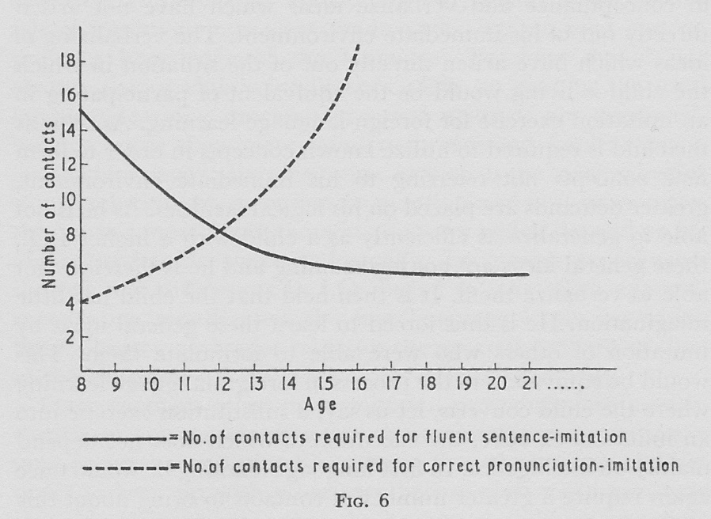

This figure also lent some credibility to the Critical Age Hypothesis, in respect of pronunciation proficiency – Lenneberg (1967) was published that very same year! – since 16 year olds did not improve their accurate reproduction of sounds no matter how many extra imitation contacts they received, and that they did not need any more contacts to achieve an acceptable level of sentence fluency.

Finally, Dodson measured the effect of retention of skills after a 12 week interruption. He discovered that the primary school children could respond almost immediately to the material learnt 12 weeks previously. He speculated that because the children required a good 15 imitation contacts to establish fluency of whole sentences (even though they needed only 4 to achieve sound accuracy) they thoroughly consolidated the learning of those sentences. “In neurological terms, this large number of original learning contacts influences the child’s neuron development and setting, thereby making consolidation more secure. The older the learner, the more his (sic) neurons will have set, thus making it more difficult for the individual to establish permanent or long-term memory pathways or circuits” (p 34-5). Indeed, he found that 13 and 14 year olds needed on average 2 to 3 reminders, and adults (16+ years old) needed on average 4, to regain control of the material missed after 12 weeks.

In summary, young children of 8 or 9 require on average only 4 imitation contacts (less than 10 seconds of contact) to establish accurate reproduction of new sounds, but require as many as 15 contacts to achieve an acceptable level of fluency of whole sentences, but this extended contact ensures thorough consolidation to enable recall at least 12 weeks later.

On the other hand, older learners require on average considerably longer imitation contact to establish accurate sound reproduction, but do not require as many contacts to achieve sentence fluency, but that lesser contact reduces consolidation. This means that the strategies for teaching L2 pronunciation differ before and after about the age of 12 – the age at which children move from primary to secondary school in many countries.

Teaching pronunciation

Dodson advocated imitation as the basic activity for developing pronunciation proficiency, a stance that has been endorsed in other, more recent, research – no more powerfully than that of Kjellin (1999). Dodson’s own focus was on classroom activities in primary and secondary schools, although he did deal with adult classes to a minor extent. His main concern was: What would work best in classes of 30+ children in school? His experiments concentrated on the learning of foreign languages in school, which led to techniques that were not only suitable in that environment but successful too. It should be conceded that most language learning and teaching around the world is conducted in school, despite the high level of interest in teaching adults in more informal settings.

Pronunciation was not taught in isolation, but was part of an integrated programme of activities. His aim was
- to make the pupil fluent and accurate in the spoken word
- to make the pupil fluent and accurate in the written word
- to prepare the pupil in such a manner that he (sic) can achieve true bilingualism (p 66).
His Bilingual Method included a range of activities that promoted an appropriate level of grammar, vocabulary, discourse convention, conversational competence and confidence building.

Pronunciation activities had to be meaningful, with words and sentences that could be immediately used in the classroom. He recommended that the most efficient way of ensuring understanding was to give a mother tongue equivalent supported if necessary by visual aids. This was the limited, precise, function of the mother tongue; it did not otherwise feature in pronunciation practice, but it was nevertheless important as the means by which learners understood what they were practising and prevented them from being distracted by trying to guess the meaning.

He advocated imitation of whole sentences as the basic technique. The teacher would give a new L2 sentence, immediately provide the meaning in the mother tongue, then proceed with multiple stimuli of that same sentence, a technique that later became known as ‘sandwiching’:
L2 sentence
Mother tongue equivalent
L2 sentence
L2 sentence
L2 sentence
…
He recommended that young children in primary school should be provided with visual aids so that they could the more easily retain the meaning of the new sentences. With meaning assured, the children would be able to concentrate on the imitation activity and so gain pronunciation proficiency. With 15 imitation contacts, the children would not only be able to pronounce the sentences with understanding, but also be able to recall them well months later. He felt that visual support was not so crucial for secondary school pupils for retaining meaning; nevertheless, understanding the meaning of what was being practised was essential.

He did not contemplate special activities based on minimal pairs, or perception and production tasks on individual consonants and vowels; he relied on children’s own capacities to perceive differences in L2 articulations. Admittedly, the secondary school pupils were not so adept at such perception and production as the younger children, but since they required at least 8 imitation contacts for both accuracy in articulations and fluency in whole sentences, they were still able to succeed without specific minimal pair type practice.

He strongly advocated the availability of printed versions of the material being practised orally, but only as a secondary focus, in the manner described above. He had discovered that print acted as a support to oral work, by providing at least the initial letters of words, and so also word boundaries themselves, which helped learners through a whole sentence. It also provided an initial acquaintance with spellings, which could then be exploited in subsequent activities.

He anticipated a rapid stimulus-response procedure, to ensure that learners responded within the 5 to 10 second retention of an accurate mental acoustic image. He envisaged a teacher saying an L2 sentence as primary focus, providing an immediate mother tongue equivalent and then proceeding with a sequence of repetitions of the L2 sentence, requiring eye contact from the whole class. The teacher would then call on individual learners to imitate the L2 sentence, but discouraged anything to be heard between the stimulus and the learner’s response – not even the learner’s name; the teacher would move around the classroom gesturing to individuals to respond. He recommended random selection of learners, so that they all had to keep alert to the possibility of being called upon. While one individual responded, others could glance at the printed version (and visual aid if available), but would still be required not only to listen to that one individual’s response, but to mouthe the sentence quietly to themselves.

To increase the number of responses per learner, the teacher should engage in what is called a ‘choral response’ by ‘conducting’ the class into a response by all at the same time. He recommended that this should be done after about ten learner responses, by which time the teacher could be sure that a good proportion of the learners were producing a good response. Obviously, in a choral response, it is impossible to detect individual faults, but this disadvantage is reduced when ten learners have already responded; by then, each learner in the class has heard ten responses from fellow learners, plus the introductory stimuli from the teacher and the teacher’s ten stimuli directed to the ten learners – quite possibly 25 contacts, and the choral response adds a 26th.

He envisaged this imitation exercise developing into a rhythmic routine, which creates a sense of wellbeing and contented progress. And every time a learner produces a good response, they should be rewarded with a smile, a thumbs up or some other positive gesture, to encourage confidence. But a teacher must avoid overdoing the exercise, just because it seems to be going well; ten minutes or so at the most! It should be possible to add new sentences within that time, and then develop a sequence in keeping with a narrative or dialogue. A demanding activity like this should be followed by a quieter one, but it might be possible to return to this active exercise later within the same lesson. This ensures that pronunciation practice is integrated directly within the wider language programme.

Final comments

My own experience of teaching pronunciation in this way is wholly positive. But as one trained in general phonetics and the phonologies of different languages, I did also supplement my teaching with specific perception and production tasks, particularly with adults (Tench 1981). It is worth a teacher’s while understanding the processes of speech, the details of the phonologies of the languages concerned, including not only the word phonology of vowels, consonants and prosodic marking, but also the simplifications in running words, and the characteristic rhythm patterns and intonation systems of whole sentences and discourse conventions.

What I learnt specifically from Dodson was that pronunciation teaching should be integrated within a holistic programme of language teaching; it should be meaningful; it is enhanced by the availability of corresponding printed material; it is best conducted in an imitation procedure with whole sentences, which themselves can be put to immediate use. I found that these principles produced successful outcomes, and I found that I enjoyed the very procedures themselves and that the learners did too!

It was wise of Derwing & Munro to look again at past masters.

References
Bley-Vroman, R & Chaudron, C (1994) Elicited imitation as a measure of second-language competence, in Tarone, E E, Gass, S M & Cohen, A D (eds) Research Methodology in Second-Language Acquisition. Hillsday, NJ: Lawrence Erlbaum Associates.
Butzkamm, W. (1980) Praxis and Theorie der bilingualen Methode. Heidelberg: Quelle & Meyer.
Caldwell, J A W (1990) Analysis of the theoretical and experiential support for Carl Dodson’s Bilingual Method. Journal of Multilingual and Multicultural Development, 11, 6: 459-479
Derwing, T M & Munro, M J (2015) Pronunciation Fundamentals: Evidence-based Perspectives for L2 Teaching and Research. Amsterdam: John Benjamins.
Dodson, C J (1967) Language Teaching and the Bilingual Method. London: Pitman.
Kjellin, O (1999) Accent addition: prosody and perception facilitate second language learning, in Fujimura, O, Joseph, B D & Palek, B (eds) Proceedings of LP98 (Linguistics and Phonetics Conference) Ohio State University. Prague: Karolinum Press.
Lenneberg, E H (1967) Biological Foundations of Language. New York: Wiley.
Prabhu, N. S. (1987) Second Language Pedagogy: a Perspective. Oxford: Oxford University Press
Tench, P (1981) Pronunciation Skills. London: Macmillan
Tench, P (1988) A Bilingual Methodology for Second Language Teaching, in Bickley, V. (ed): Languages in Education in a Bi-lingual or Multi-lingual Setting, Institute of Language in Education, Hong Kong p399-419. Reprinted in Immersion Language Teaching: Selected Readings 1, Distance Education Centre, University of Southern Queensland, Australia, 1995.

